Melody Tone frequency
130.81Hz, 146.83Hz, 164.83Hz, 174.61Hz, 196Hz, 220Hz, 246.94Hz
261.63Hz, 293.66Hz, 329.63Hz, 349.23Hz, 392Hz, 440Hz, 493.88Hz = c,d,e,f,g,a,b
523.25Hz, 587.33Hz, 659.26Hz, 698.46Hz, 783.99Hz, 880Hz, 987.77Hz

//ARR value = 0.1M/130.8 = 764.5

// program ARR register
uint32_t ToneArr[]={0,764,681,607,573,510,454,405,382,340,303,286,255,227,202,191,170,152,143,128,114,101};

uint32_t ToneHz[]={0,131,147,165,175,196,220,247,261,294,329,349,392,440,493,523,587,659,698,784,880,988};

//Basic tone
uint8_t note_basic[]={1,2,3,4,5,6,7,1+7,2+7,3+7,4+7,5+7,6+7,7+7,1+14,2+14,3+14,4+14,5+14,6+14,7+14};
// Happy Birthday Song
uint8_t note_happy_song[]={5,5,6,5,1+7,7,5,5,6,5,2+7,1+7,5,5,5+7,3+7,1+7,7,6,4+7,4+7,3+7,1+7,2+7,1+7 };

uint16_t beat_happy_song[]={250,250,500,500,500,1000,250,250,500,500,500,1000,250,250,500,500,500,500,1500, \
250,250,500,500,500,1500};

// Little Star Song
uint8_t note_little_star[]={1,1,5,5,6,6,5,4,4,3,3,2,2,1,5,5,4,4,3,3,2,5,5,4,4,3,3,2,1,1,5,5,6,6,5,4,4,3,3,2,2,1};

uint16_t beat_little_star[]={500,500,500,500,500,500,1000,500,500,500,500,500,500,1000,500,500,500,500,500,500, \ 1000,500,500,500,500,500,500,1000,500,500,500,500,500,500,1000,500,500,500,500,500,500,1000};

//Little Bee Song
uint8_t note_little_bee[]={5,3,3,4,2,2,1,2,3,4,5,5,5,5,3,3,4,2,2,1,3,5,5,3, 2,2,2,2,2,3,4,3,3,3,3,3,4,5,5,3,3,4,2,2,1,3,5,5,1};

uint16_t beat_little_bee[]={250,250,500,250,250,500,250,250,250,250,250,250,500,250,250,500,250,250,500,250,250,250,250,1000, \ 250,250,250,250,250,250,500,250,250,250,250,250,250,500,250,250,500,250,250,500,250,250,250,250,1000};
小星星
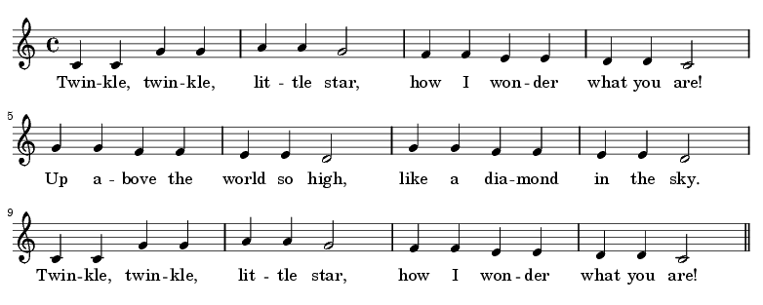

生日快樂
